Hursh Desai

Decision Models and Analytics

Professor Zhang

09/18/2019

**Lease Planning**

Cox Cable Company needs to lease warehouse storage space for 5 months at the start of the year. It knows how much space will be required in each month, and it can purchase a variety of lease contracts to meet these needs. For example, it can purchase 1-month leases in each month from January to May. It can also purchase 2-month leases in January through April, 3-month leases in January through March, 4-month leases in January and February, or a 5-month lease in January. In total, there are 15 possible leases it could use. It must decide which leases to purchase and how many square feet to purchase on each lease. Since the space requirements differ month to month, it may be economical to lease only the amount needed each month on a month-by-month basis. On the other hand, the monthly cost for leasing space for additional months is much less than for the first month, so it may be desirable to lease the maximum amount needed for the entire 5 months. Another option is the intermediate approach of changing the total amount of space leased (by adding a new lease and/or having an old lease expire) at least once but not every month. Two or more leases for different terms can begin at the same time. The space requirements (in square feet) and the leasing costs (in dollars per thousand square feet) are given. The task is to find a leasing schedule that provides the necessary amounts of space at the minimum cost.

**Conclusion and Recommendation**

Can minimize cost by leasing according to this leasing strategy:

|  |  |  |  |  |  |
| --- | --- | --- | --- | --- | --- |
| Lease Time | Jan | Feb | Mar | Apr | May |
| 1 |  |  | 5,000sqft |  | 10,000sqft |
| 2 |  |  |  |  |  |
| 3 |  |  |  |  |  |
| 4 |  |  |  |  |  |
| 5 | 15,000sqft |  |  |  |  |

Lease for 5 months in January at 15,000sqft, then an additional 1 month of 5,000 sqft in March followed by an additional 1 month of 10,000sqft in May. Cost is cut down to

$16.5 mil total.

**Managerial Problem Definition**

Decisions to be made – How to structure the leases over the course of 5 months while remaining within the sqft restrictions.

Objective – minimize the total cost of all the lease(s).

Restrictions – the required sqft for each lease from Jan-May is as follows: 15,000; 10,000; 20,000; 5,000; 25,000. The cost of each lease duration is also restricted depending on how many months you lease (1-5) and is as follows: $280/sqft, $450/sqft, $600/sqft, $730/sqft, $820/sqft.

**Model Formulation**

Decision Variables:

Space leased / month / duration

XJ1, XJ2, XJ3, XJ4, XJ5, XF1, XF2, XF3, XF4, XF5, XM1, XM2, XM3, XM4, XM5

XA1, XA2, XA3, XA4, XA5, XMA1, XMA2, XMA3, XMA4, XMA5

Sqft Amt of Each lease (Xsqft)

Objective Function:

Minimize Cost: 280(XJ + XF + XM + XA + XMA)1 + 450(XJ + XF + XM + XA + XMA)2 + 600(XJ + XF + XM + XA + XMA)3 + 730(XJ + XF + XM + XA + XMA)4 + 820(XJ + XF + XM + XA + XMA)5

Constraints:

Xcost: XC1 = 280, XC2 = 450, XC3 = 600, XC4 = 730, XC5 = 820

Xsqft: XSQ1 = ≥ 15,000 , : XSQ2 = ≥ 10,000, : XSQ3 = ≥ 20,000, : XSQ4 = ≥ 5,000, : XSQ5 = ≥ 25,000

**Solution Methodology (below)**

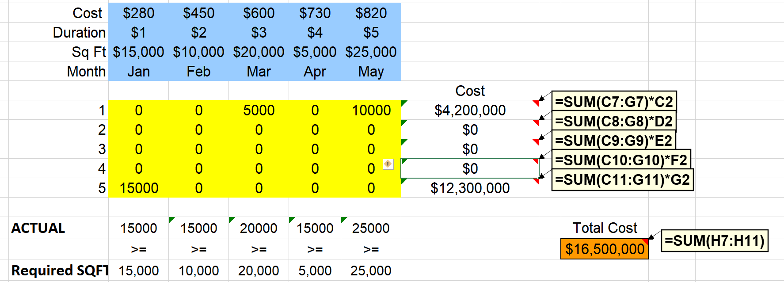

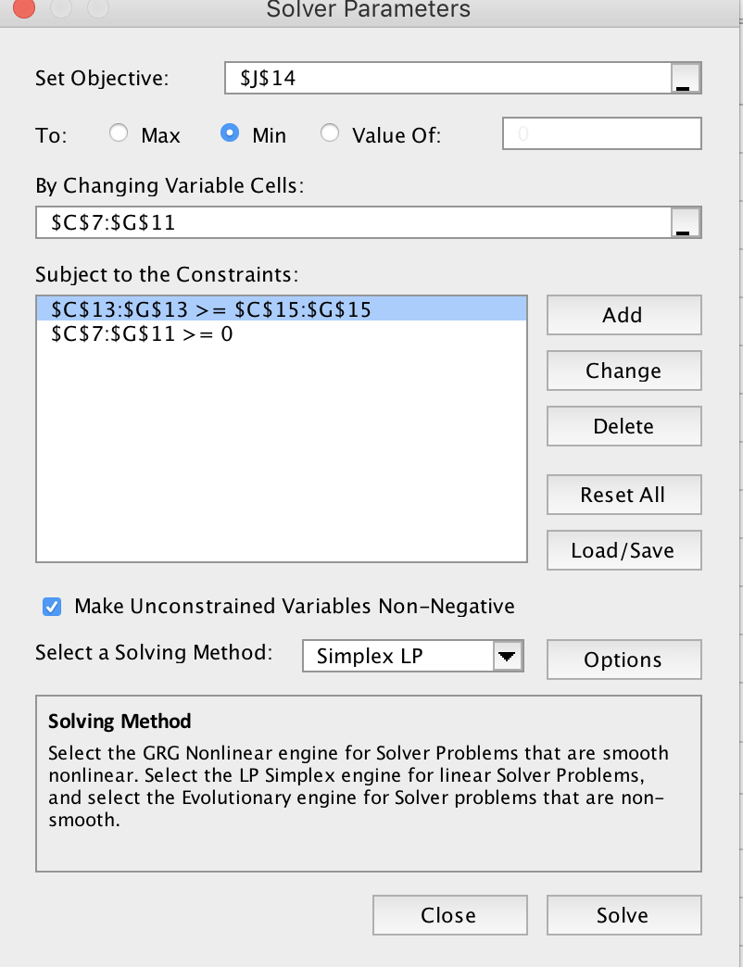

As we can see from the decision variables and constraints shown above, it is optimal to lease for 5 months in January at 15,000sqft, then an additional 1 month of 5,000 sqft in March followed by an additional 1 month of 10,000sqft in May.

**Discussions (part b)**

Up until the required sqft for January reaches 20,000, the cost will increase by $260 for each 1 sqft. When January’s requirement reaches more than 20,000sqft, it will continue to increase the total cost by $280/sqft.

When you increase the sqft requirement for January, you will lease as many sqft for 5 months as you can based on the remaining months’ requirements. For example, when changed to a requirement of 20,000sqft, you would lease 20,000sqft for 5 months in January, then an additional 5,000sqft for one month based on the May requirement.

**Case: Jet Green**

JetGreen flies three airplanes, using a “hub-and-spoke” flight schedule between Houston and three cities, Chicago, Miami, and Phoenix. These three cities are the “spokes” connected by the Houston “hub.” Once each day, the three airplanes fly from the spoke cities to Houston.

They arrive nearly simultaneously at Houston, then connecting passengers change aircraft during a 1-hour layover, and the three airplanes return to their starting cities. One set of six flights (3 inbound to Houston and 3 outbound) is called a bank . A bank can serve passengers flying on 12 different routes : three inbound direct routes (Chicago or Miami or Phoenix into Houston), three outbound direct routes (Houston to Chicago or Miami or Phoenix), and six routes requiring two flights each (Chicago– Miami, Chicago– Phoenix, Miami– Phoenix, Miami– Chicago, Phoenix– Chicago, and Phoenix– Miami).

JetGreen charges a regular price for a one-way ticket on each route. Exhibit 2.1 shows the regular prices. Following a well-established policy, JetGreen offers a discount to senior travelers. The ticket price for a senior traveler is 90% of the regular price, rounded down to the next smaller integer number of dollars. (For example, on the Houston– Phoenix route, the senior ticket price is $112.) The marginal cost of flying a passenger on each route is virtually zero.

Each of JetGreen’s three airplanes contains 260 seats. Exhibit 2.2 shows demand for the routes in a bank at the regular price, and Exhibit 2.3 shows the demand from seniors (at the discounted ­ price). These figures apply to the times at which JetGreen flies, and they show that passenger demand exceeds airplane capacity on every flight segment. For example, on the flight from Miami to the Houston hub, the total regular demand is the sum of demands for three passenger routes (Miami to Houston or Chicago or Phoenix), totaling 72 + 105 + 68 = 245 passengers. For seniors, the comparable figure is 6 + 15 + 8 = 29, and the total is 245 + 29 = 274. Because only 260 passengers can travel on the Miami– Houston flight, at least 14 passengers represent lost demand.

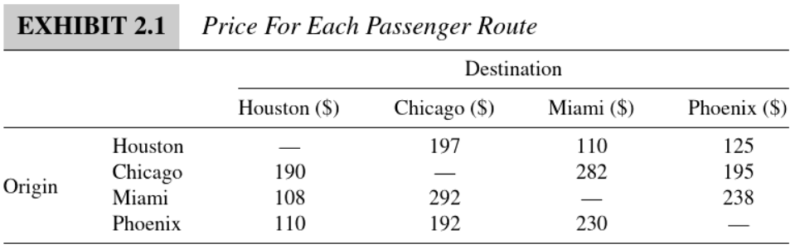

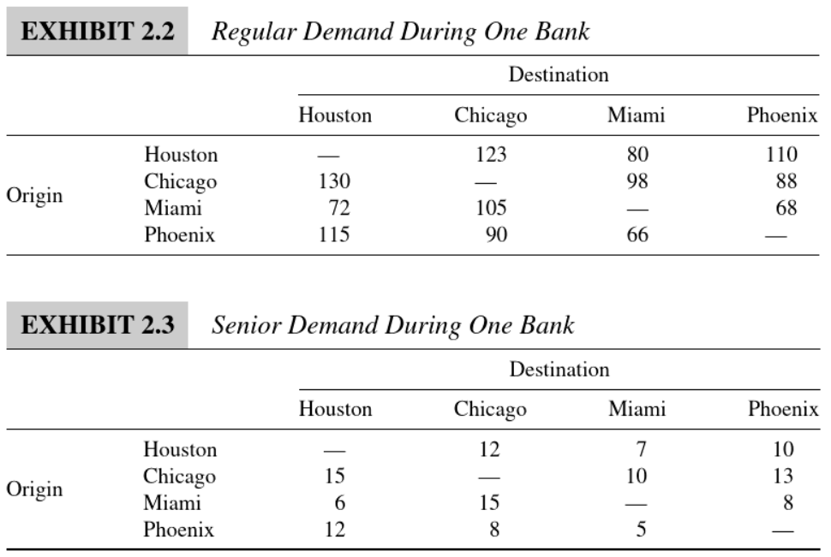

When the total demand for a particular flight is larger than the available capacity, an airline can decide whether to accept or reject an offer to buy a ticket for a particular route. Controlling sales in this way to maximize revenue is called revenue management . For example, JetGreen may decide to sell large numbers of tickets for the Miami– Houston and Miami– Chicago routes but might severely restrict sales of the Miami– Phoenix tickets. Given the data earlier, JetGreen might sell tickets to 78 Miami– Houston passengers, 120 Miami– Chicago passengers, and only 62 Miami– Phoenix passengers, thus filling all 260 seats on the Miami– Houston flight. All 14 lost demands would then come from the Miami– Phoenix route.

Assuming that the various demands in Exhibits 2.2 and 2.3 are known, JetGreen wants to determine the number of tickets it should sell to regular and senior passengers on each route.

**Conclusion and Recommendation**

Jet Green can maximize revenue for their flights with the below seat allocation.

Fig 1.

|  |  |  |  |  |  |
| --- | --- | --- | --- | --- | --- |
| **Origin** | **Destination** | **Fare Class** |  | **Seats**  **Allocated** |  |
| Houston | Chicago | Q |  | 0 |  |
| Houston | Miami | Q |  | 7 |  |
| Houston | Phoenix | Q |  | 10 |  |
| Chicago | Houston | Q |  | 0 |  |
| Chicago | Miami | Q |  | 4 |  |
| Chicago | Phoenix | Q |  | 0 |  |
| Miami | Chicago | Q |  | 1 |  |
| Miami | Houston | Q |  | 6 |  |
| Miami | Phoenix | Q |  | 8 |  |
| Phoenix | Chicago | Q |  | 0 |  |
| Phoenix | Miami | Q |  | 5 |  |
| Phoenix | Houston | Q |  | 12 |  |
| Houston | Chicago | Y |  | 123 |  |
| Houston | Miami | Y |  | 80 |  |
| Houston | Phoenix | Y |  | 110 |  |
| Chicago | Houston | Y |  | 94 |  |
| Chicago | Miami | Y |  | 98 |  |
| Chicago | Phoenix | Y |  | 64 |  |
| Miami | Chicago | Y |  | 105 |  |
| Miami | Houston | Y |  | 72 |  |
| Miami | Phoenix | Y |  | 68 |  |
| Phoenix | Chicago | Y |  | 31 |  |
| Phoenix | Miami | Y |  | 66 |  |
| Phoenix | Houston | Y |  | 115 |  |

With this optimal seat allocation, the total revenue would be $218,244.00.

**Managerial Problem Definition**

Decisions to be made - Allocation of seats to different ODIFs

Objective- maximize revenue

Restrictions-

1. Each plane has only 260 seats.
2. Demand constraint: seats allocated cannot be more than demand for seats

**Model Formulation**

Decision Variables-

24 Decision Variables: seats allocation for the 24 ODIFs

(Each ODIF in Fig 1)

Objective Function-

Maximize $\sum_{i=1}^{24}{F_{i}*x_{i}}$

Constraints-

$$For i=24 x_{i} ≤ D_{i}$$

|  |  |  |  |  |
| --- | --- | --- | --- | --- |
|  |  | **LHS** |  | **RHS** |
| **Capacity** | **Leg 1 (C-H)** | 260 | <= | 260 |
| **Leg 2 (M-H)** | 260 | <= | 260 |
| **Leg 3 (P-H)** | 229 | <= | 260 |
| **Leg 4 (H-C)** | 260 | <= | 260 |
|  | **Leg 5 (H-M)** | 260 | <= | 260 |
|  | **Leg 6 (H-P)** | 260 | <= | 260 |

**Solution Methodology**

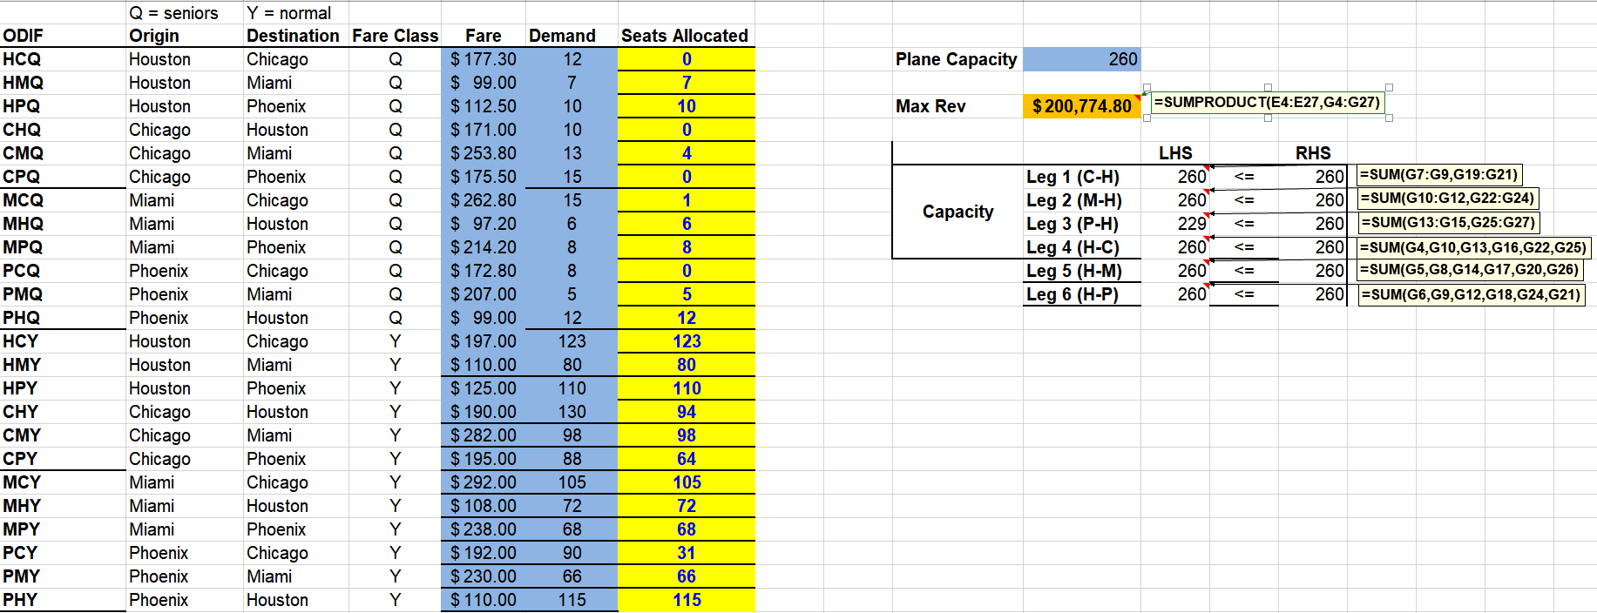

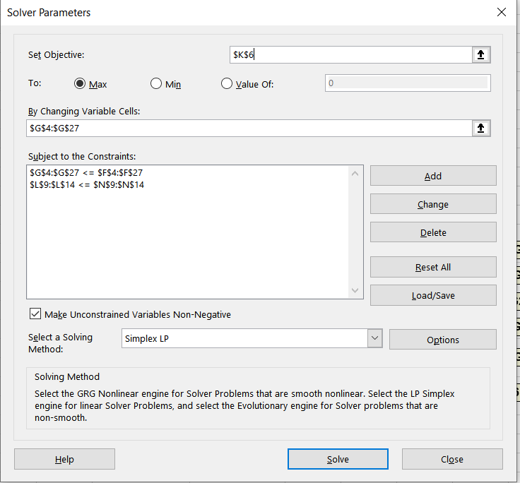

As we can see from the decision variables and constraints shown above, the optimal solution is to allocate the number of seats on the planes by what is indicated by our solution. i.e. Houston to Chicago you would allocate 12 seats flight for the senior fare class and so on. With these seat allocations the total revenue to Jet Green would be $218,244.00.

**Discussions**

This is given that demand will not change after this snapshot which also means we won’t be doing any overbooking for flights in order to make up for the fact that we don’t have a varying demand.